**Introduction to wavelets families and choosing criteria**

Introduction

Wavelets are used extensively in many varied technical fields. They are usually presented in mathematical formulas, but we can actually be understood in terms of simple comparisons of correlations (similarity) with the signal being analyzed. Wavelets can tell us where something (signals that frequency is changing over time) is located, in other words wavelets can define *non-stationary* signals.

Task

Define different wavelet families and understand where and how do we use them.

Most popular wavelet families and their description:

1. ***Shannon*** or ***"Sinc"*** wavelets can find events with specific frequencies. (These are similar to "sin(x)/x").

2. ***Haar*** wavelets (the *shortest*) are good for edge detection and reconstructing binary pulses. (Haar wavelet would match an abrupt discontinuity). The Haar wavelet is the first and simplest orthonormal wavelet basis. The Haar wavelet is conceptually simple, memory efficient, exactly reversible without the edge effects characteristic of other wavelets and computationally cheap. The Haar transform does not have overlapping windows, and reflects only changes between adjacent pixel pairs. It uses just two scaling and wavelet function coefficients, thus calculates pair wise averages and differences.

*Note: Haar-Wavelets are only suitable for elementary work. Usually more complex wavelets are necessary.*

3. **Coiflets** wavelets are good for data with self-similarities (fractals) such as financial trends. Coiflets was originally derived from the Daubechies wavelet. It has an even higher computational overhead and uses windows that overlap more. it uses six scaling and wavelet function coefficients, so increase in pixel averaging and differencing leads to a smoother wavelet and increased capabilities in several image-processing techniques (de-noising images, etc.). The filter follows the same structure as both Haar and Daubechies. It calculates both averages and differences using the same format, only with six adjacent pixels. The Coiflet wavelet also follows the mirror technique. (From Wavelet-based Texture Classification of Tissues in Computed Tomography)

4. **Daubechies** wavelets family is the most popular wavelet family used for texture feature analysis, due to orthogonal and compact support abilities. The Daubechies wavelet uses overlapping windows, so the results reflect all changes between pixel intensities. Since Daubechies averages over more pixels, it is smoother than the Haar wavelet. The Daubechies D4 transform has four wavelet and scaling coefficients. The sum of the scaling function coefficients is also one, thus the calculation is averaging over four adjacent pixels. *Example: Db20 would match a chirp signal*

*Most popular mother wavelets:*

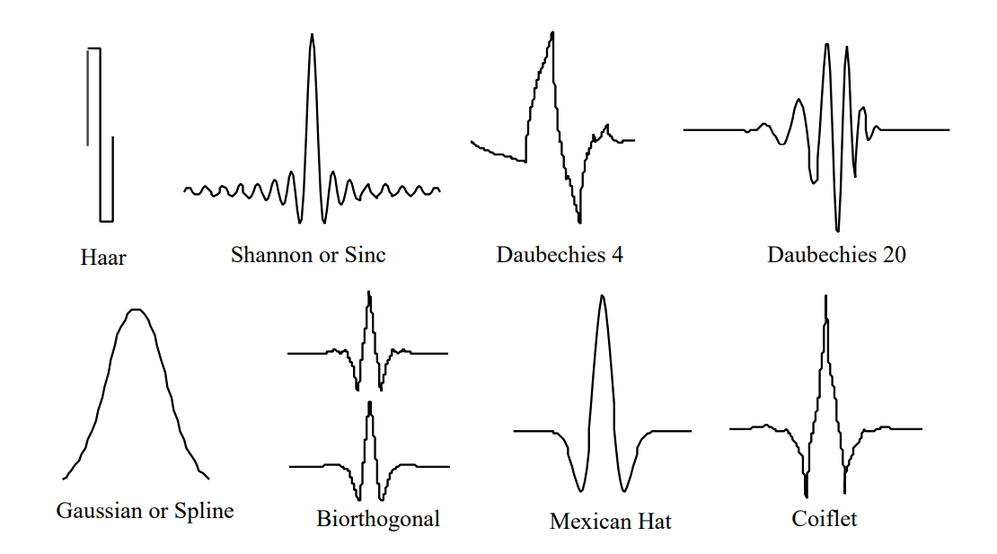

Criteria for proper mother wavelet choosing:

The main concept in wavelet analysis of signal is similarity of the signal and the selected mother wavelet so the important methods are:

ENERGY:

energy tell us about similarity of the signal and mother wavelet which used and mother wavelet with highest energy is select

ENTROPY:

tell us about data missing of the signal and mother wavelet which used and mother wavelet with lowest entropy is select

*Note from Aleksandras:*

*WAVELET CHOISE*

*- high frequency - smaller wave # better time localization*

*- low frequency - longer wavelet (and also time window) -> also lower precision*

*in other words:*

*selectivity in Frequency (Heisenberg uncertainty principle)*

*More selective wavelet = less compact support (less selective in time)*

*VANISHING MOMENTS = sign of complex wavelet*

*+ = more accurate representation*

*- higher number of vanishing moments, longer support is needed*

*p vanishing moments: polynomial up to p-th order will not be identified with wavelet*

*REGULARITY*

*low*

*higher: smoother -> more vanishing points*

*Source: <https://www.youtube.com/watch?v=ZnmvUCtUAEE>*

Results:

* In the face off Haar wavelet, Daubechies wavelet families are more complex, and generally has a higher computational overhead. Contrary to our initial expectations, in some works, the Haar wavelet is performs better results than Daubechies wavelets. It depends on what we want to do and what we want achieve...
* In many applications, the Haar wavelet function is very attractive because it guarantees low redundancy in the algorithm that is used.
* Haar wavelet is used to detect sudden changes. The others are used to smooth the images and for texture analysis.
* Daubechies wavelet can be correctly applied for speech characterization and achieved good results.
* Selected wave must match original signal closely
* Daubechie wavelets vanishing moments:
  + The filter with k=1 vanishing moment corresponds to the Haar filter.
  + The filter with k=2 vanishing moments corresponds to the famous D4 wavelet, which compresses perfectly linear signals.
  + The filter with k=3 vanishing moments compresses perfectly quadratic signals

Proposal:

We need to find mother wave that closely matches original signal, it could be difficult and not efficient while our signal contains noise, proposal is to perform EMD on original signal and then wavelet transforms on IMF's so it is easier to find good matching wave for IMF signal.

Sources:

*https://www.researchgate.net/post/Can_anybody_compare_Haar_Daubechies_coiflet_and_symlet_wavelets*

*http://www.conceptualwavelets.com/docs/wavelets_ch1.pdf*

*http://feihu.eng.ua.edu/NSF_TUES/w7_1a.pdf*

*http://www.conceptualwavelets.com/docs/wavelets_ch1.pdf*

Robert Tarasevič

2020.02.13